SCB-AALAS Lunch & Learn!

FREE LUNCH

FREE EVENT

October 17th, 2018

11am-12pm

Natural Science I Ring Rd.

Irvine, CA 92617

Room 1114
Come join us for a talk on Rabbit Pair Housing presented by:
Barrie Axen, MSTD, Senior Business Development Director at Covance.
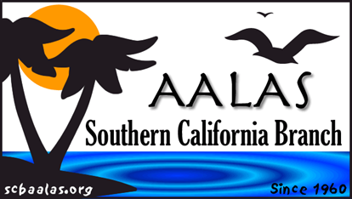
RSVP to programs@scbaalas.org by Friday, October 12
**Parking: $2/hr ticket can be purchased in the kiosks in Lot 16.

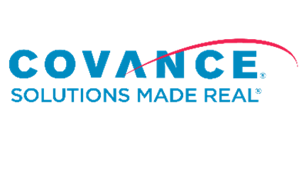
Sponsored by

